YouTube controller.

I started to play guitar back in the dark ages, before the internet. Imagin sitting in front of a phonograph and dropping the needle on a track you’re trying to learn. Listen for a few seconds and try and figure out the notes. Repeat as needed.

Today with the internet and YouTube, there are thousands of guitar lessons available for free. You can look up lyrics and chords and even see live performances.

I found out about YouTube keyboard shortcuts that allow one to pause and rewind the video. With a foot-controlled pedal, you don’t have to remove your fingers from the guitar. This simple project was fun to build and code.

I used a “Teensy 2.0” Arduino. <https://www.pjrc.com/store/teensy.html> It’s a small and cheap processor with a USB port.

The Teensy was configured as a USB type as “keyboard + mouse + joystick”. That allows us to send keyboard commands to our computer.

//------------------The Following is a list of possible Youtube keyboard shortcuts

//Toggle play/pause the video k or Spacebar

//Go back 5 seconds Left arrow

//Go back 10 seconds j

//Go forward 5 seconds Right arrow

//Go forward 10 seconds l

//Skip to a particular section of the video (e.g., 5 goes to the video midpoint) Numbers 1-9 (not the keypad numbers)

//Restart video 0 (not the keypad number)

//Go to Full Screen mode f

//Exit Full Screen mode Escape

//Go to beginning of video Home

//Go to end of video End

//Increase volume 5% Up arrow

//Decrease volume 5% Down arrow

//Increase speed Shift+> (may not work in all browsers)

//Decrease speed Shift+< (may not work in all browsers)

//Move forward 1 frame when video is paused . (period)

//Move backward 1 frame when video is paused , (comma)

//Mute/unmute video m

//Turn captions on/off c

//Cycle through options for caption background color b

//Move to the previous video in a playlist Shift+p

//Move to the next video in a playlist Shift+n

Started out as a 90 degree plastic pipe from Home Depo. The one that you pull electrical lines through.

Cut the pipe in half and use pieces from the unused half for the 4 pedals.

Here we see (back 10 seconds) (back 5 seconds) (pause) and (forward 10 seconds)

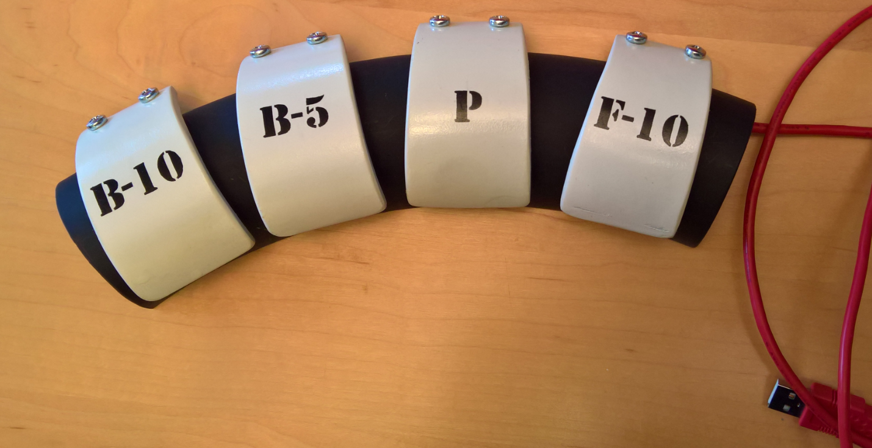

The 4 (normally open) pushbutton switches are connected to the Arduino input pins. We short the pins to ground to activate the function.

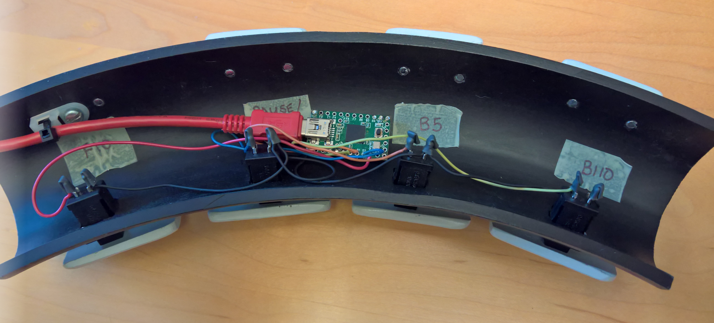

I collect these songs (chords and lyrics) usually in word files, so I was constantly switching between the internet browser and the word app. So, I added a 5th button on the side that switches between apps. More of a Windows command. Alt + Tab can be used to switch between any running program that has an application-level window.

PINOUT:

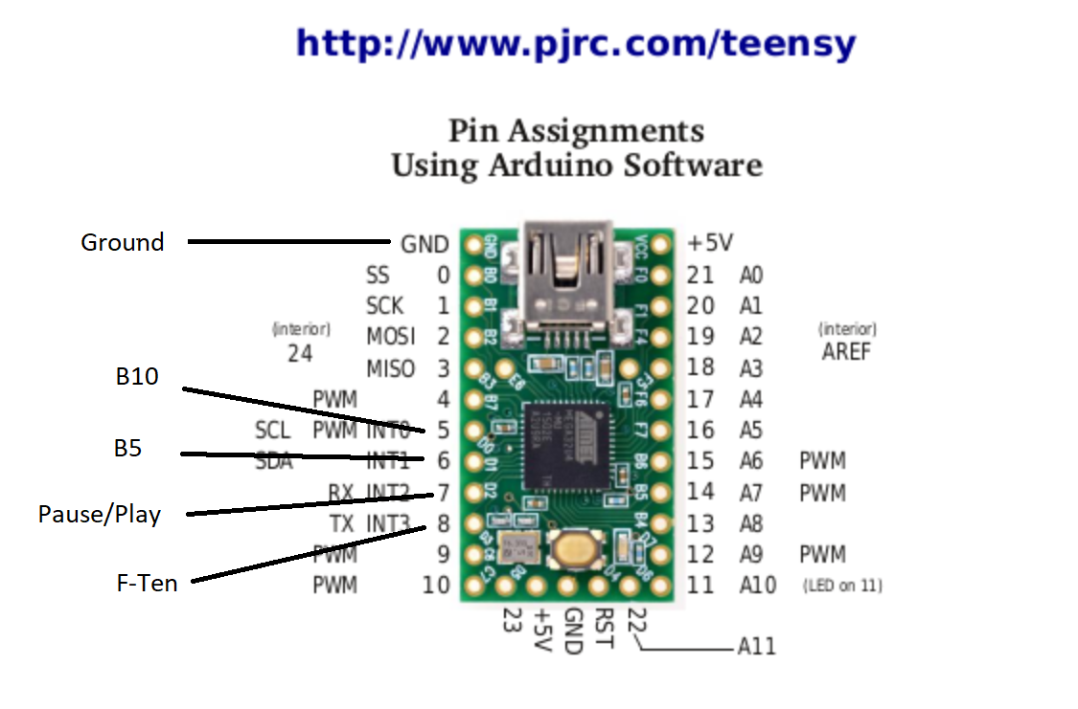

Alt +Tab

--------------------------------------------------------------------------------------------------------------------------------

// Code:

// Youtube control to pause, jumpback and play the video stream with foot controled pushbuttons

// Designed to to used while holding a guitar learning music on Youtube.

// Hardware is a Teensy 2.0 processor connected to 4 push buttons. The buttons are:

// Bten or reverse the video 10 seconds

// Bfive or reverse the video 5 seconds

// PAUSE pause the video

// Ften Forwared the video 10 seconds

// How about we add a 5th button Alt +(Tab) to switch between apps. browser to MS Word and back

// These pushbutton switches short the Teensy pins to ground (active low signals).

#include <Keyboard.h>

const int led = LED_BUILTIN; // I used the LED on the Teensy as a good debug tool.

int Bten = 5; // Pin 5 the back ten seconds button

int Bfive = 6; // Pin 6 the back 5 seconds button

int pause = 7; // Pin 7 pause button

int Ften = 8; // Pin 8 Forward ten seconds

int alt_tab = 9; // Pin 9 Alt +Tab will switch between windows apps

void setup() {

pinMode(Bten, INPUT_PULLUP); //configure the pushbutton switch inputs with pull-ups. Normally high then active low

pinMode(Bfive, INPUT_PULLUP);

pinMode(pause, INPUT_PULLUP);

pinMode(Ften, INPUT_PULLUP);

pinMode(alt_tab, INPUT_PULLUP);

Keyboard.begin(); // Keyboard library

}

void loop()

{

//---------------------REWIND 10 SECONDS----------------------------------------

if(digitalRead(Bten)==LOW) //if the button is pressed

{

digitalWrite(led, HIGH); // Turn on the LED when button is pushed

Keyboard.write('j'); //Send the message lower case j = go back ten seconds

delay(500); // This 1/2 second delay prevents multiple button pushes

}

//----------------------REWIND 5 SECONDS------------------------------------------

if(digitalRead(Bfive)==LOW) //if the button is pressed

{

digitalWrite(led, HIGH);

// all this just to send a left arrow key which = go back five seconds.

// https://www.pjrc.com/teensy/td_keyboard.html

Keyboard.set_key1(KEY_LEFT);

Keyboard.send_now();

// release all the keys at the end

Keyboard.set_key1(0);

Keyboard.send_now();

delay(500);

}

//------------------------PAUSE----------------------------------------------------

if(digitalRead(pause)==LOW) //if the button is pressed

{

digitalWrite(led, HIGH);

Keyboard.write('k'); //Send the message lower case k = pause

delay(500);

}

//------------------------FORWARE 10 SECONDS----------------------------------------

if(digitalRead(Ften)==LOW) //if the button is pressed

{

digitalWrite(led, HIGH);

Keyboard.write('l'); //Send the message lower case l = go forward 10 seconds

delay(500);

}

//------------------------Alt + Tab----------------------------------------

if(digitalRead(alt_tab)==LOW) //if the button is pressed

{

digitalWrite(led, HIGH);

Keyboard.set_modifier(MODIFIERKEY_ALT); //Set the Alt modifier

Keyboard.send_now(); //Send the alt modifier

Keyboard.press(KEY_TAB); // Send the TAB key

Keyboard.release(KEY_TAB); //quite sending tab key

Keyboard.set_modifier(0); //Turn off the modifier key

Keyboard.send_now(); //send that

delay(500);

}

//---------------------------------------------------------------------------

else

{

digitalWrite(led, LOW);

}

}

//the end-------------------------------------------------------------------------------

//------------------The Following is a list of possible Youtube keyboard shortcuts

//Toggle play/pause the video k or Spacebar

//Go back 5 seconds Left arrow

//Go back 10 seconds j

//Go forward 5 seconds Right arrow

//Go forward 10 seconds l

//Skip to a particular section of the video (e.g., 5 goes to the video midpoint) Numbers 1-9 (not the keypad numbers)

//Restart video 0 (not the keypad number)

//Go to Full Screen mode f

//Exit Full Screen mode Escape

//Go to beginning of video Home

//Go to end of video End

//Increase volume 5% Up arrow

//Decrease volume 5% Down arrow

//Increase speed Shift+> (may not work in all browsers)

//Decrease speed Shift+< (may not work in all browsers)

//Move forward 1 frame when video is paused . (period)

//Move backward 1 frame when video is paused , (comma)

//Mute/unmute video m

//Turn captions on/off c

//Cycle through options for caption background color b

//Move to the previous video in a playlist Shift+p

//Move to the next video in a playlist Shift+n

How to compile and load:

Again using a Teensy 2.0 (the most basic and least expensive)

Downloaded the latest Arduino IDE. Currently March 2021 loaded 1.8.13 (or the latest)

Then got the latest Teensyduino application that adds libraries, download tools and such. I found the latest version here:

[Teensyduino: Download and Install Teensy support into the Arduino IDE (pjrc.com)](https://www.pjrc.com/teensy/td_download.html)

The latest (at this date) was 1.53

In the Arduino IDE tool. Cut and paste the code into the editor.

Select the Teensy 2.0 in the tools menu: Also select the USB type as “keyboard + mouse + joystick”

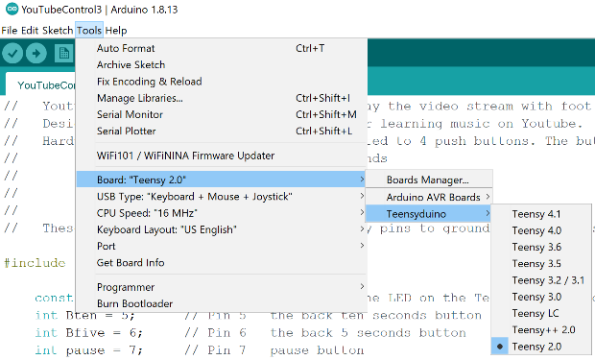 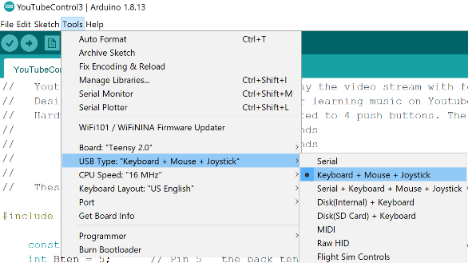

Connect the Teensy 2.0 board to your PC with a USB cable. Select Verify then follow the directions to upload.

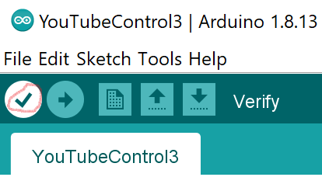 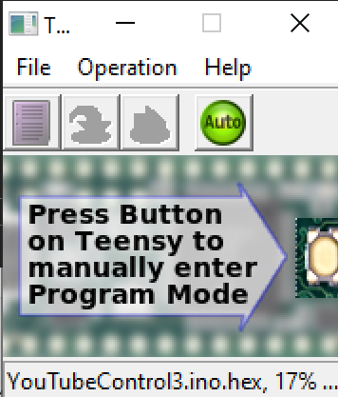

Play guitar and have fun! --Rohahn